Minutes of the Ordinary Council Meeting of Broughton Gifford Parish Council held on
Wednesday 9th September 2026 in the Village Hall starting at 7:30pm

Present: Cllrs Hooper (Chair), Cooper, Corbin, Healy, Norris, & Wright.
Absent: Cllrs Baker, Catanach, Griffiths, Monk, & Packer.
In attendance: Karen Spence (Parish Clerk), Cllr Andrew Griffin (Wiltshire Council), PC Fran Thornell (Wiltshire Police) and 3 members of the public.

Public Participation: The chair invited 1 member of the public to speak reference plans to alleviate flooding in the village including further discussion about storm drains. Resolved: Councillor Griffin will raise the storm drains at the flood working group. Clerk to add the storm drain outside the pub (which had tar tipped into it during some resurfacing work) on MyWilts and flag to both Highways and Drainage. Increased funding was discussed – clerk to additionally request that Broughton Gifford is added to list for future improvements from this increase.
The second member of the public had attended to advise Councillors that he would no longer be able to fulfil the contract for playground and cemetery maintenance. Resolved: The chair thanked the contractor for their service and clerk will make arrangements for this matter to be discussed at the next meeting and arrangements for advertising the contract for tender will be agreed.
The chair invited the third member of the public to speak in relation to the grant opportunities relating to the Stone Barn renovations (the latter discussion is minuted under item 2627/105).

Councillor Griffin spoke about new planning regulations which restricts the ability of a Councillor to ‘call in’ a planning application. PC Thornell introduced herself and took away some actions with regard to school parking.

PRELIMINARIES
2627/091. Acceptance of apologies: Apologies were received from Cllrs Catanach, Griffiths, Monk and Packer.

2627/092. Declarations of interest:
None received.
In accordance with the code of conduct when a councillor declares a non-pecuniary interest, they take no part in the discussion or vote. When a councillor declares a pecuniary interest, they are required to leave the room during discussion and voting.
2627/093. Dispensations: None received

2627/094. Exclusion of the Press and Public: There were no items for which members of the press/public needed to be excluded.

PREVIOUS MEETING

2627/095. Previous meeting minutes:
Minutes of the meeting held on 29th July 2026 were formally agreed and signed as a correct record of the meeting and have since been posted onto the website.

The following mattes arising were discussed:
- Live Action List was reviewed and updated

FINANCE
2627/096.
- Invoices: Council noted and approved the following expenditure:
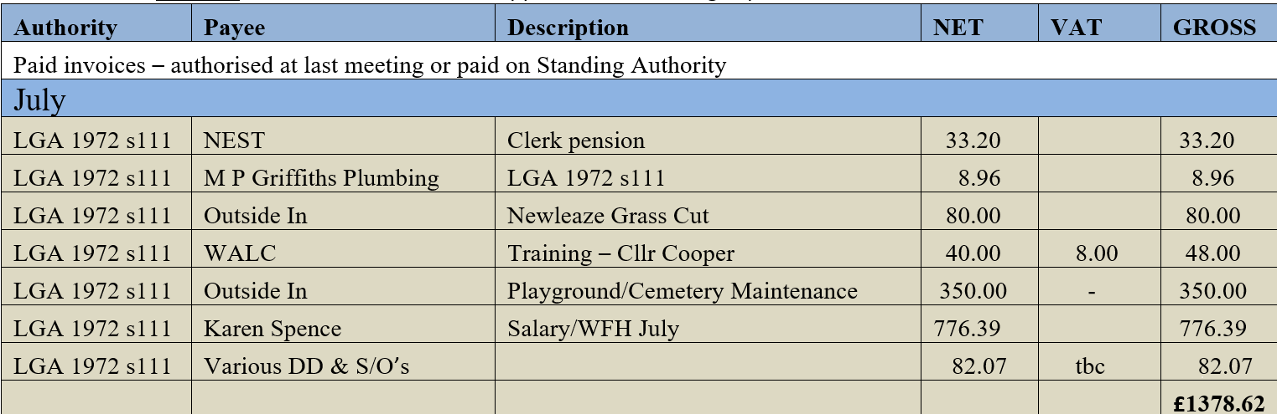
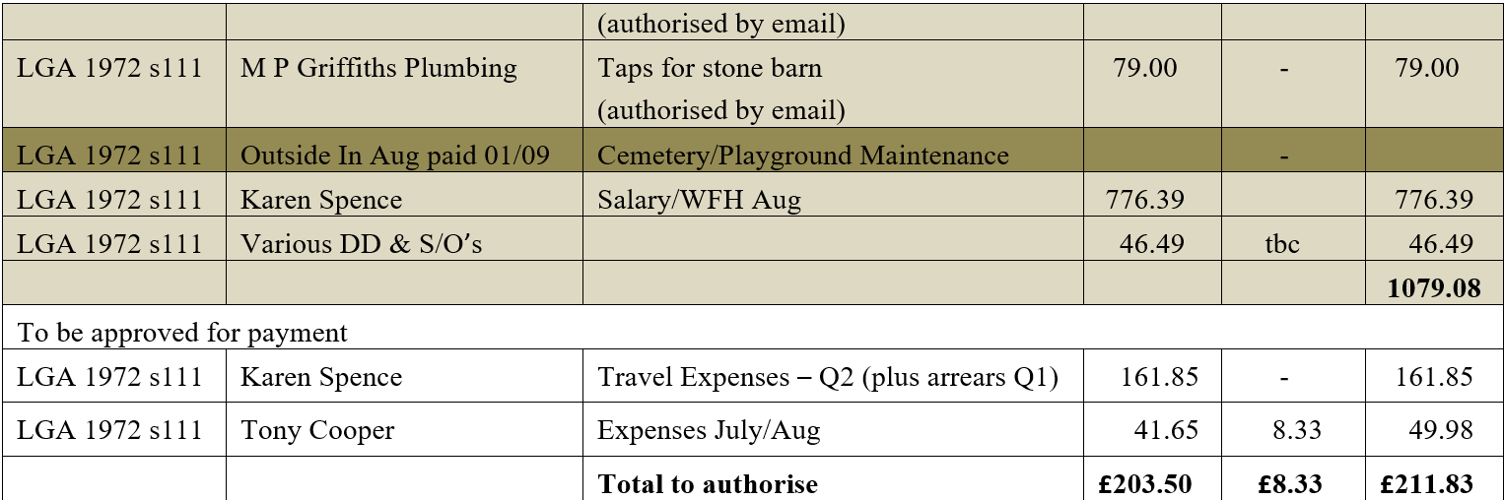

- Receipts: Council noted receipts of £323.00 (July) and £206.00 (Aug) 2026 (cemetery fees).
- Account balances: –
As at 31st July 2026
Current account: £ 15,174.14
Savings account: £ 50,904.76
Total all balances: £66,078.90

As at 31st August 2026
Current account: £ 14,301.06
Savings account: £ 50,927.07
Total all balances: £65,228.13

- Councillor Griffiths was not present and therefore the bank reconciliations for July and August will be signed off at the next meeting.

PLANNING
2627/097. Planning:
- There were no planning applications made since the last meeting for Council to consider.

(Please note in planning matters the Council acts as the consultee of the Principal Authority. The Principal Authority being the deciding body.)
- Council considered revised documents submitted for the ALDI proposed redevelopment of the former CountryWide site. Resolved: the revised plans do not address previous objections – clerk to submit a further comment to this effect.

2627/098. Planning decisions:
There were no planning decisions made since the last meeting for Council to note.

MAINTENANCE

2627/099. Parish Steward:
Council noted the list of works conducted by the Parish Steward during his visit in September.
2627/100. Parish Steward:
Council discussed the list for the Parish Steward for the October visit. Resolved: Clerk to contact Parish Steward and request he looks at potholes across the village and clearance of any fallen leaves (particularly those blocking gullies).
Council noted that the next dates for the Parish Steward is scheduled to attend Broughton Gifford are 1st and 5th October 2026.
2627/101. Village Maintenance Report (standing agenda item):
Council received a verbal report from Councillor Cooper considered the following items related to village maintenance:
- Councillor Cooper advised that he has managed to recruit a volunteer to undertake some of the maintenance tasks around the village. He requested a £30 standing authority for maintenance supplies which will be purchased and claimed back on expenses; this was approved. Resolved: Cllr Cooper will project manage the new volunteer, any items in excess of the £30 (per month) limit will be brought to Council for prior approval.
- Parking in the vicinity of the War Memorial and damage to the area: This had been requested for inclusion by councillors and has since been resolved by the construction company. Resolved: this will be monitored whilst the construction continues and councillors will ensure any residual damage is made good.
- Ground Maintenance and Flood control – email from resident: Councillors considered an email from a resident regarding ground maintenance and flood prevention. It was agreed that the Parish Council do what we are able to undertake within limited budgets/responsibility. Resolved: Clerk to respond advising and asking whether the pipe mentioned has been reported on MyWilts. Cllr Cooper will clear the brambles as it is acknowledged that these are overhanging a footpath.

and March
COMMONS/CEMETERY/FOOTPATHS
2627/102. Speed Indicator Device:
The Highways Improvement request will be considered at a meeting scheduled for 10th September which the Clerk will attend. The rumble strips for the traffic survey have been installed in the wrong place. This has been reported but no response received as yet. Further update will be available at the October meeting.

2627/103. Cemetery Plots:
This item (to consider a report from Clerk regarding future sales of advance purchase EROB’s) was further deferred to the October meeting.

2627/104. Proposed diversion of footpath:
Council considered an email from Wiltshire Council regarding a proposed diversion of Footpath BGIF15. The proposal, from the perspective of the Parish Council, was deemed to be a reasonable and practical solution. However, it was drawn to councillors’ attention that the land owner and a farmer who has access through the yard, had not been consulted as part of this process. Resolved: Clerk to respond advising of this.

ADMINISTRATION

2627/105. Stone Barn (standing agenda item):
Crispin Springler was in attendance to present the work he has undertaken on grant options appraisal. It was noted that there are a number of smaller potential grant sources which might present an opportunity, however it is unlikely that it will be possible to secure a large grant to cover a significant portion of the cost. Resolved: Crispin is happy to undertake the work to submit relevant applications but they will need to be submitted BY the Parish Council and there will be some information required to do this: Resolved: Clerk to provide required information to Crispin and to act as first point of contact during this scoping/application phase. Once any work begins Councillor Norris will act as overall Project Manager.

2627/106. Clerk/RFO/Cemetery Manager:
Council considered a short report from the clerk reviewing the current situation since the relocation of the current clerk and outlining future options. Resolved: Council agreed in principle with the approach for recruitment of a replacement clerk and this will be discussed again in October to agree timescales for advertising etc.
Council additionally noted and approved the NALC negotiated cost of living increase backdated to 01/04/2026 and agreed payment of arrears for this increase in the Clerks October salary.

2627/107. Internal Audit review:
Council received, noted and signed off a letter from the Internal Auditors in respect of the basis on which they act as internal auditors of the Council and the respective areas of responsibility of the Council and of ourselves.”

2627/108. Items for Parish magazine & Notice Boards:
No additional items were identified for inclusion in the parish magazine. It was agreed that noticeboards needed updating with the standard notices as some of these are out of date. Resolved: Clerk will ensure noticeboards are updated over the summer including some additional notices for the cemetery noticeboard.

2627/109. Notice of items to be taken into consideration at the next meeting in September:
The following additional items were identified for inclusion on the agenda for the next meeting.
- Cemetery – discussion about future sale of EROB (advance plot sales).
- Flood Planning

2627/110. Correspondence:
Councillors noted and acknowledged the following items of correspondence forwarded to all Councillors since the last meeting.

2627/111. Date of the next meeting:
Council noted that the next meeting will be held on Wednesday 14th October 2026 at 7:30 pm in the village hall. All are welcome to attend.

With no further business, the meeting closed at 21:35

