Minutes of the Ordinary Council Meeting of Broughton Gifford Parish Council held on
Wednesday 29th July 2026 in the Village Hall starting at 7:30pm
(Meeting rescheduled from 08/08/2026)

Present: Cllrs Hooper (Chair), Baker, Cooper, Griffiths, Healy, Monk, Norris.
Absent: Cllrs Catanach, Corbin, Packer, Wright
In attendance: Karen Spence (Parish Clerk), and 6 members of the public.

Public Participation: The chair invited a representative of the 6 members of the public present to speak about the Public Notice which had recently been displayed outside the Baptist Chapel.

Resolved: The Parish Council were supportive of submitting a letter to the Trustees of the charity which manages the trust in support of the congregations’ objection to the proposed closure of the facility. Clerk to work with the member of the public to draft a letter for approval of the Chair and submit to the trustees by the deadline date of 22nd August.

PRELIMINARIES
2627/070. Acceptance of apologies: Apologies were received from Cllrs Catanach, Corbin, Packer and Wright.

2627/071. Declarations of interest:
None received.
In accordance with the code of conduct when a councillor declares a non-pecuniary interest, they take no part in the discussion or vote. When a councillor declares a pecuniary interest, they are required to leave the room during discussion and voting.
2627/072. Dispensations: None received

2627/073. Exclusion of the Press and Public: There were no items for which members of the press/public needed to be excluded.

PREVIOUS MEETING

2627/074. Previous meeting minutes:
Minutes of the meeting held on 10th June 2026 were formally agreed and signed as a correct record of the meeting and have since been posted onto the website.

The following mattes arising were discussed:
- Live Action List was reviewed and updated

FINANCE
2627/075.
- Invoices: Council noted and approved the following expenditure: 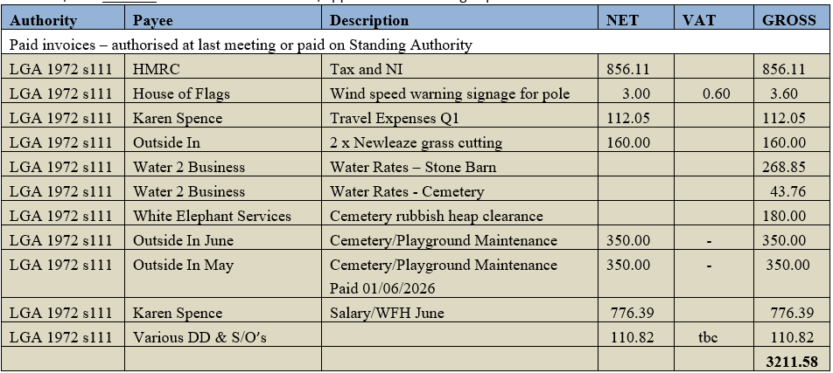

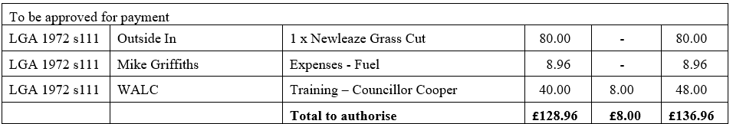

- Receipts: There were no receipts for Council to note for June 2026.
- Account balances: – As at 30th June 2026

- The bank reconciliations for June were signed off by Councillor Griffiths.

PLANNING
2627/076. Planning:
- There were no planning applications made since the last meeting for Council to consider.

(Please note in planning matters the Council acts as the consultee of the Principal Authority. The Principal Authority being the deciding body.)

2627/077. Planning decisions:
Council noted the following planning decisions made since the last meeting.

MAINTENANCE

2627/078. Parish Steward:
Council noted the list of works conducted by the Parish Steward during his visit in July.
2627/079. Parish Steward:
As there will be no visits for August Council discussed lists for Parish Steward for the September visit. As this is still some way off Council requested that, if possible, PS should take a look at any overgrown vegetation in areas that fall within his remit in addition to the regular list. Resolved: Clerk to contact Parish Steward.
Council noted that the next dates for the Parish Steward is scheduled to attend Broughton Gifford are 1st and 2nd September 2026.
2627/080. Village Maintenance Report (standing agenda item):
Council received a verbal report from Councillor Cooper considered the following items related to village maintenance:
- Bench on the Common (Hiscocks): seat was collapsing and Cllr Cooper has repaired. Teak oil was purchased and will be submitted in expenses claim in September.
- Flagpole windspeed label has been attached.
- Cemetery: there is a ‘burial in progress’ and some marking stakes in the shed which can be used. A bicycle and lawnmower which don’t belong to PC have been being stored in the shed for some time. Resolved: Cllr Cooper will place a notice on the Facebook page to advise that these should be collected and they will be disposed of if they remain in situ after a given period.
- Notice Boards: Many of the notices require updating. Resolved: Clerk to update standard notices and post copies. Councillors have volunteered to do the physical posting if this proves problematic for clerk.
- Fir tree at entrance to Saw Mills has been inspected by tree expert (Jeff Hudson) and we are advised it is dead and unsafe. Resolved: Clerk to contact Highways team at Wiltshire Council.
- Email reference parking around the village and the condition of double yellow lines (for information): Councillors noted the email. Resolved: Clerk to chase up the double yellow lines opposite the school with Parking Services and respond to email.
- Ditch Maintenance update – clerks’ email to all councillors regarding ‘Top 5’ identification: Councillors noted that clerk had received no response to her email requesting they identify Top 5 and it was re-stated that all gullies need clearing for prevention. Resolved: Clerk to contact WC Highways advising this and stating that priority would be Melksham Lane.
- Bus Service Improvement Plan and Bus shelter email from Wiltshire Council: Councillors noted email from Wiltshire Council re wider bus service plan. Resolved: Clerk to seek further information about what this means for the Bus Shelter funding scheme.
- Millennium Pond – clearance & trees at top of Common – Bramble removal: This was discussed and it was agreed that the tree area was not a job that would require contractors at considerable cost. Resolved: Improvement of the area of trees at the top of the of the Common will be ‘parked’ for a year. Cllr Hooper to clear some of the brambles in the autumn (October).

and March
COMMONS/CEMETERY/FOOTPATHS
2627/081. Speed Indicator Device:
This is progressing but requires decision to be made on the Highways Improvement request submitted in relation to the traffic calming. Cllr Monk advised that an additional HIR will need to be submitted for the sockets and posts. Clerk advised that the Traffic Survey request had been submitted online and that no acknowledgment had been received: Resolved: Clerk to submit additional HIR and follow up on the Traffic Survey.

2627/082. Cemetery Plots:
This item (to consider a report from Clerk regarding future sales of advance purchase EROB’s) was deferred to the September meeting.

ADMINISTRATION

2627/083. Stone Barn (standing agenda item):
This is still ongoing; a decision needs to be taken with regard to the extra toilet/sink as the drainage for these items has proved to be problematic. It is felt that, due to the lack of grant funding opportunities, this is something that could be removed from the current scheme and included at a later date. It was considered that the current scheme should comprise; roof, infrastructure, doors and ensuring watertight. This will be discussed at the next meeting.

2627/084. Declarations of Interest:
Council considered an email from Wiltshire Council (Monitoring Officer) re changes required to Declarations of Interest for Councillors. Resolved: Clerk to make further enquires to establish what is required and implement the actions that can be done by admin. Councillors will be notified of any action they need to undertake themselves

2627/085. Winter Preparations for 2026/27:
Council to consider an email from Wiltshire Council regarding requests for winter equipment and supplies. Resolved: Clerk to email and advise that nothing is required this year.

2627/086. Clerk/RFO/Cemetery Manager – future plans for the post:
Council received a verbal update from the clerk reviewing the current situation since her relocation also outlining future options. The recommended action was supported in principle and this will be followed up with a written report in either September or October.

2627/087. Items for Parish magazine & Notice Boards:
For the September parish magazine Cllr Cooper will include an item encouraging householders to ensure their hedges and verges are cut and tidied. As minuted at agenda item 2627/080 the notice board standard notices require updating. No additional items were identified for inclusion in magazine or on website/notice boards:

2627/088. Notice of items to be taken into consideration at the next meeting in September:
The following additional items were identified for inclusion on the agenda for the next meeting.
- Report from Clerk re future of the Clerk/RFO/Cemetery manager role (may be deferred to October)
- Cemetery – discussion about future sale of EROB (advance plot sales).

2627/089. Correspondence:
There were no items of correspondence (forwarded to all Councillors) for councillors to note.

2627/090. Date of the next meeting:
Council noted that the next meeting will be held on Wednesday 9th September 2026 at 7:30 pm in the village hall. All are welcome to attend.

With no further business, the meeting closed at 21:00

