Minutes of the Ordinary Council Meeting of Broughton Gifford Parish Council held on
Wednesday 10th June 2026 in the Village Hall starting at 7:30pm

Present: Cllrs Hooper (Chair), Baker, Catanach, Cooper, Corbin, Griffiths, Monk, Norris, Packer & Wright
Absent: Cllr Healy.
In attendance: Karen Spence (Parish Clerk), and Councillor Griffin (Wiltshire Council).

Public Participation: No members of the public were present.

Wiltshire Councillor Andrew Griffin gave an update on the LHFIG and the Highways Improvement Forms submitted by the Clerk on behalf of the Parish Council. Resolved: The suggested positioning for the ‘Road Liable to flooding’ signs was agreed and Cllr Griffin/Cllr Monk will seek to arrange a date for the Highways Engineer to visit the village and consider options for the traffic calming and the Speed Indicator Device. Clerk to send the revised version of the Mill Lane HIP (including speed limit request) to Councillor Griffin. NB a date for engineer visit has since been agreed.

PRELIMINARIES
2627/047. Acceptance of apologies: Apologies were received from Cllr Healy.

2627/048. Declarations of interest:
None received.
In accordance with the code of conduct when a councillor declares a non-pecuniary interest, they take no part in the discussion or vote. When a councillor declares a pecuniary interest, they are required to leave the room during discussion and voting.
2627/049. Dispensations: None received

2627/050. Exclusion of the Press and Public: There were no items for which members of the press/public needed to be excluded.

PREVIOUS MEETING

2627/051. Previous meeting minutes:
Minutes of the meeting held on 13th May 2026 were formally agreed and signed as a correct record of the meeting and have since been posted onto the website.

The following mattes arising were discussed:
- Live Action List was reviewed and updated
- Highways Improvements – Mill Lane – see above
- Newleaze Grass Cut – discussed the frequency of this as has been cut more often over the last couple of months. Resolved: important that it is cut as and when needed but will keep this under review in terms of spend against budget.
- Cricket Club – The level of monies owed from 2024/25 and 2025/26 was discussed alongside discussion about selection of provider when current fixed rate ends. Resolved: it was agreed that Parish Council should cover the standing charge elements of both electricity and water provision. This applies to the two outstanding bills and will continue going forward. Responsibility was delegated to the clerk to authorise provision in accordance with the best available quote (quotes arranged via the same broker who sourced provision 3 years ago.
- Clerk confirmed of Posting of Notice of Public Rights and Statement of Accounts/Financial Report and gave an update re submission of paperwork to external auditor (including Assertion 10 Action Plan not yet complete).

FINANCE
2627/052.
- Invoices: Council noted and approved the following expenditure:
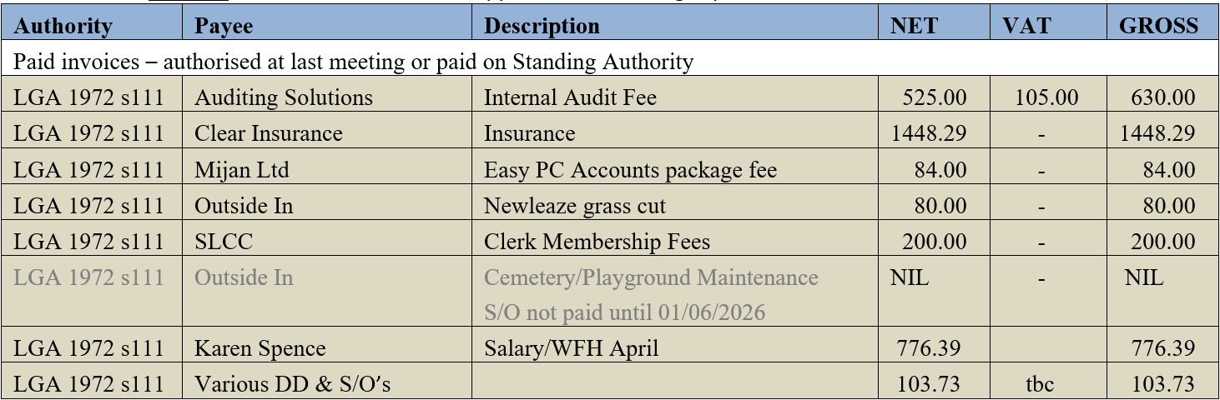
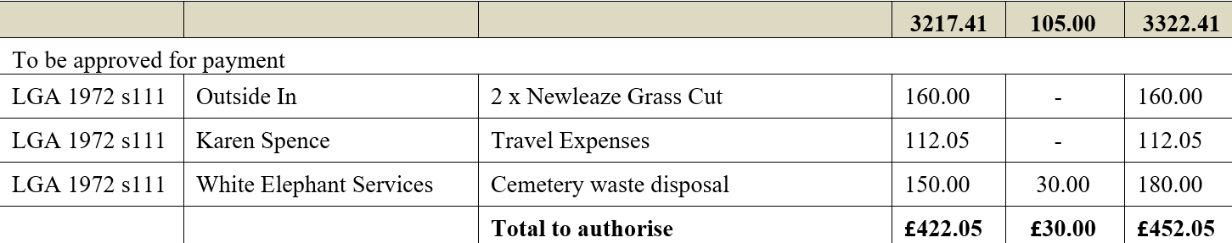

In addition, Council also gave authority for clerk to pay 2x Water2Business bills for water rates for cemetery and stone barn. These had been delivered to the post box and collected by Cllr Griffiths but had not been brought to the meeting or notified in advance. They will be formally approved at the July meeting.

- Receipts: Council noted receipts of £1554.00 for May 2026 (Cemetery £196, WC closed churchyard grant £1358.00).
- Account balances: – As at 31st May 2026
- The bank reconciliations for May were signed off by Councillor Griffiths.

PLANNING
2627/053. Planning:
- Council considered the following planning applications received since the previous meeting.
No objections were raised for this application which had been approved by the planning committee outside of the meeting because of the deadline for comments.

(Please note in planning matters the Council acts as the consultee of the Principal Authority. The Principal Authority being the deciding body.)

2627/054. Planning decisions:
Council noted the following planning decisions made since the last meeting.
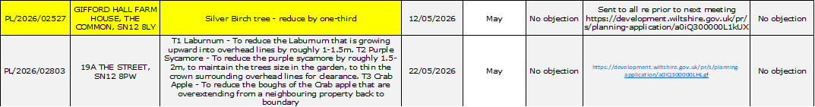

MAINTENANCE

2627/055. Parish Steward:
Council noted the list of works conducted by the Parish Steward during his visit in June and expressed appreciation for the amount of work undertaken after a lengthy period of abstractions.
2627/056. Parish Steward:
Council discussed lists for Parish Steward for the July visit and acknowledged that there was probably still a lot of work for the steward to catch up on. It was requested that, if possible, PS should take a look at the increasing number of potholes on Melksham Lane. Resolved: Clerk to contact Parish Steward.
Council noted that the next dates for the Parish Steward is scheduled to attend Broughton Gifford are 1st and 2nd July 2026.
2627/057. Village Maintenance Report (standing agenda item):
Council received a verbal report from Councillor Cooper considered the following items related to village maintenance:
- Cemetery: Now that the waste heap has been removed, the area under the former willow tree and adjacent to the shed is now ready to be prepared for reseeding. Cllr Cooper advised that there are lots of bramble roots and ivy underneath a thin top layer and that these should be removed prior to seeding. Resolved: Cllr Hooper will inspect.
- Cemetery Shed: Councillor Cooper requested that it was made clear that the ‘inspection’ of the shed roof would be from ground level only. Resolved: Clerk to update action.
- Yew Tree in Cemetery: One of the branches is banging up against the gable end of the shed and could damage the fabric of the building. Resolved: Cllr Hooper will inspect.

and March
COMMONS/CEMETERY/FOOTPATHS
2627/058. Speed Indicator Device:
This is ongoing to update this month whilst we await visit from the highways engineer who will help to consider this alongside other issues such as the traffic calming. It is necessary to have another Traffic Survey as the one conducted previously (2024) is considered out of date. Resolved: Clerk to complete online request form for new survey ensuring it outlines need for the new survey to take place during Stonar School term-time (summer break dates 03/07/26 to 07/09/26.

ADMINISTRATION

2627/059. Stone Barn (standing agenda item):
Council was advised that Councillor Griffiths now has 3 valid quotes although there is some inconsistency between the 3 about what is included. One discrepancy which needs to be resolved is around the additional toilet/sink. There are issues regarding drainage but it was agreed that the toilet and sink are key elements in relation to health and safety requirements. It was agreed that an update on the grant options appraisal (being produced by Crispin Shringler) would need to be available in order for a final decision about preferred quote to be made: Resolved: Clerk to contact Crispin and see if he is available to attend the next meeting. Cllr Griffiths to further look into drainage options for toilet/sink.

2627/060. Recycling Unit offer:
Council considered an email from Fortune Eximports Ltd offering the opportunity to a locate textile recycling point in the village. Resolved: This was a commercial offer not a charity. It was agreed that previous experience of similar indicates this can be problematic. Resolved: Clerk to respond and advise of this decision.

2627/061. Wiltshire Wildlife – Potential Open Day at Willows Care Farm:
Council to consider an email from Wiltshire Wildlife reference suggestions for parking during a proposed Open Day in October and options for parking: Resolved: Clerk to respond and advise that the village hall carpark would be the best option (supply village hall email address for them to contact directly with this request).

2627/062. Parish Council Meeting Minutes – request re village magazine:
For Council considered and discussed an email from a resident (to village magazine) requesting a return to publication of a summary of the minutes. Resolved: It was not considered appropriate to return to this approach which takes up considerable space in the magazine and is not of interest to the majority. It was agreed that Cllr Wright will print off 2 copies of the most recent approved minutes every month and arrange for them to be available in each of the pubs.

2627/063. Re-establishment of Local Youth Network:
Council considered an email from Wiltshire Council reference representation from Parish Councils on this group. Resolved: Clerk to respond and establish whether the initiatives being planned will extend out into the villages in terms of provision.

2627/064. Moving of Defibrillator from school:
The Clerk updated Councillors that the school had now agreed for the defibrillator to be moved during the school holidays and have supplied a telephone number for their site manager so that we can liaise direct between him and John Drummond who will be moving it. Resolved: Clerk to forward the number to Cllr Cooper; Cllr Wright will inform SWAST.

2627/065. Councillor Training:
The Clerk provided information about specific online training provision from Wiltshire Association of Local Councils (WALC). Additionally, she informed that, if we are going to be able to provide a ‘Yes’ response with regard to Assertion 10 on the AGAR, it will be a requirement that Councillors undertake regular training around Data Protection etc. Resolved: Clerk to book Councillor Cooper onto the training and to continue to inform of future dates.

2627/066. Items for Parish magazine & Notice Boards:
No additional items were identified for inclusion in magazine or on website/notice boards:

2627/067. Notice of items to be taken into consideration at the next meeting in July:
The following additional items were identified for inclusion on the agenda for the next meeting.
- Report from Clerk re future of the Clerk/RFO/Cemetery manager role
- Millennium Pond – clearance
- Trees at top of Common – Bramble removal
- Cemetery – discussion about future sale of EROB (advance plot sales).

2627/068. Correspondence:
Councillors noted the following items of correspondence forwarded to all Councillors since the previous meeting. NB: Councillor Griffin had been able to clarify some of the implications of this at his briefing during the public participation session.
2627/069. Date of the next meeting:
Council noted that the next meeting will be held on Wednesday 8th July 2026 at 7:30 pm in the village hall. All are welcome to attend.

With no further business, the meeting closed at 20:58 pm

