Minutes of the Ordinary Council Meeting of Broughton Gifford Parish Council held on
Wednesday 13th May 2026 in the Village Hall starting at 7:30pm

Present: Cllrs Hooper (Chair), Baker, Cooper, Griffiths, Healy, Monk & Wright
Absent: Cllrs Corbin & Norris
In attendance: Karen Spence (Parish Clerk), and Councillor Griffin (Wiltshire Council).

Public Participation: No members of the public were present.

Wiltshire Councillor Andrew Griffin gave an update on the blocked footpath which now appears to be open and accessible at one end of the residents’ property. It was pointed out that it was definitely still inaccessible at the other end. This issue is ongoing and options being considered/negotiated by the Rights of Way Officer. Discussion also took place around Highways Improvement Forms for the village as submitted to the May 2026 LHFIG. It was agreed that Cllr Griffin would contact the Highways Team to arrange a visit to further consider where to site Flood Warning signs in Mill Lane and to look at options for traffic calming.

PRELIMINARIES

2627/023. Acceptance of apologies: Apologies were received from Cllrs Corbin & Norris

2627/024. Declarations of interest:
None received.
In accordance with the code of conduct when a councillor declares a non-pecuniary interest, they take no part in the discussion or vote. When a councillor declares a pecuniary interest, they are required to leave the room during discussion and voting.
2627/025. Dispensations: None received

2627/026. Exclusion of the Press and Public: There were no items for which members of the press/public needed to be excluded.

PREVIOUS MEETING

2627/027. Previous meeting minutes:
Minutes of the meeting held on 8th April 2026 were formally agreed and signed as a correct record of the meeting and have since been posted onto the website.

There were no matters arising to be discussed however it was planned to go through the revised ‘live’ action log. The clerk was unable to access this and therefore it will be reviewed next month. Resolved: Clerk will circulate the live list once updated with actions from this meeting.

FINANCE
2627/028.
- Invoices: Council noted and approved the following expenditure

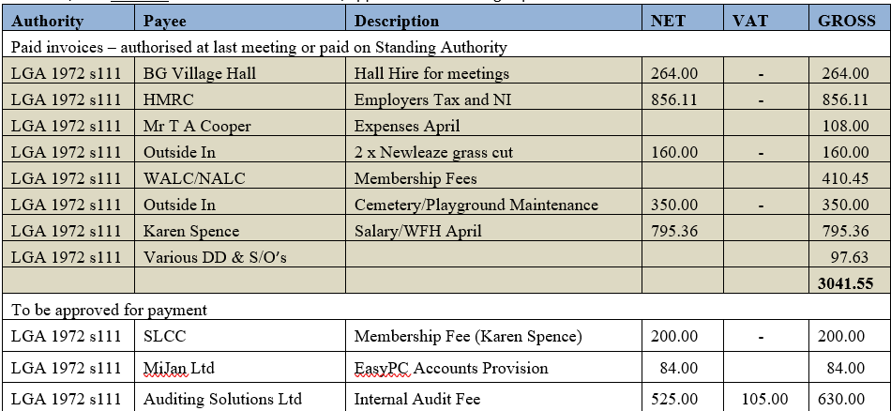
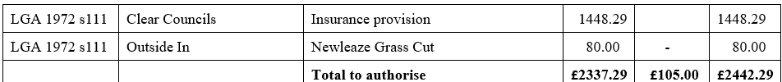

- Receipts: Council noted receipts of £10466.85 for April 2026 (Cemetery £350, Precept ½ 10116.85).
- Account balances: – As at 30th April 2026
- The bank reconciliations for April were signed off by Councillor Griffiths.

2627/029. Internal Audit 2026:
Council received and noted the Internal Audit report for 2025/26. The clerk briefed the Council on the new requirements for Assertion 10 and the reasons for the resulting ‘No’ response for this year. Resolved: Clerk to formulate an action plan to reflect discussions during meeting about the barriers to having a fully compliant website.

2627/030. Year-end finance:
Council approved the year end accounts (subject to a few identified amendments) for the year ended 31/03/2026. This was duly signed off by the Chair and the Clerk.

2627/031. Annual Governance and Accountability Report (AGAR)
- Council approved and signed (Chair) Section 1 of the AGAR
- Council approved and signed (Chair) Section 2 of the AGAR

PLANNING
2627/032. Planning:
- Council considered the following planning applications received since the previous meeting.
No objections were raised for any of these applications
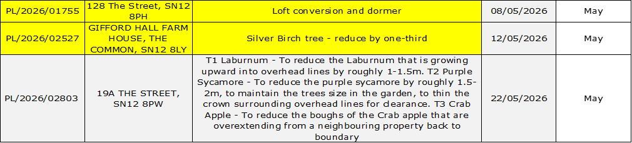

(Please note in planning matters the Council acts as the consultee of the Principal Authority. The Principal Authority being the deciding body.)

2627/033. Planning decisions:
Council noted the following planning decisions made since the last meeting.

MAINTENANCE

2627/034. Parish Steward:
Council noted that the Parish Steward was again unable to make a visit in May due to being diverted to other work. Clerk briefed Councillors about the new notification process and feedback was given to Cllr Griffin (on his request) about the changes to the process.
2627/035. Parish Steward:
Council discussed lists for Parish Steward and acknowledged that, as it had been an extended period since the previous visit, there is likely to be a great deal of work to undertake. It was requested that, if possible, PS should take a look at Newleaze footpath and verge/kerb plus weeds across the village Resolved: Clerk to contact Parish Steward.
Council noted that the next dates for the Parish Steward is scheduled to attend Broughton Gifford are 1st and 2nd June 2026.
It was additionally noted that the road surface around Newleaze is badly breaking up.

2627/036. Village Maintenance Report (standing agenda item):
Council received a verbal report from Councillor Cooper considered the following items related to village maintenance:
- Quote received for removal of the waste heap in cemetery (left after removal of the willow). Council noted that a second quote requested from an alternative contractor had not been provided. Resolved: Cllr Cooper to contact supplier and accept quote.
- Cemetery Shed: Council was advised that shed roof (although currently in good order) may contain asbestos. The recommendation from HSE is that such roofs, if in good condition, should be left rather than removed. Resolved: Shed roof will be periodically inspected to ensure it remains in good order (Cllr Cooper/maintenance ‘team’).
- Clatterbridge: Repaired. Resolved: Cllr Cooper will do a full inspection next month.
- Flag pole: The self-adhesive sign that was previously attached detailing maximum wind speed is no longer there. Resolved: Cllr Cooper will investigate options for replacement.
- Cllr Cooper sabbatical: Appeal for help has proved fruitful and someone has been identified someone to assist. This individual has already been helping out with a periodic tidy up of the playpark which will continue. This month he has also cleared leaves from the bus shelter and repainted the grit bin.

and March
COMMONS/CEMETERY/FOOTPATHS
2627/037. Speed Indicator Device:
This is ongoing. Clerk updated about delay relating to the LHFIG discussion re moving of the speed limit sign which will now not be discussed until September meeting. Resolved: Given that it is unlikely there will be any action on the Highways issue this year, it was decided to move forward with the purchase of the device(s) and install with a view to moving once the Highways matter is actioned. Resolved: Cllr Monk to progress formal quotes.

2627/038. Request from Scouts re Great Chalfield Run:
Council considered and approved a request from BG Scouts to park vehicles for the Great Chalfield run on the Common (as in previous years). Resolved: Clerk to notify.

2627/039. Request from Able Scaffolding re permission to launch a hot air balloon:
Council considered and approved a request from Able Scaffolding to launch a hot air balloon from BG Common. Resolved: Clerk to notify and request telephone call (Cllr Monk/Cllr Wright/Cllr Griffiths.

ADMINISTRATION

2627/040. Stone Barn (standing agenda item):
Council was advised that quotes received to date were not complete and need to be revised to include additional items. Clerk advised that it will still be necessary to secure an additional quote from one of the contractors who had previously provided estimates. Resolved: Cllr Griffiths will follow this up for further consideration at the next meeting.

2627/041. Review of Fixed Asset and Risk Registers:
Council to reviewed and readopted the risk register for 2027 with no amendments. It was noted that it may be necessary to include a specific additional risk around Assertion 10 dependent on what level of action is agreed around future compliance. The Fixed Asset Register had already been reviewed during the Annual Council meeting (immediately prior to this meeting) and therefore was not included in this item.

2627/042. Village Hall – Increase in hire charges:
Council noted an email from the Village Hall committee advising of an increase in charges from June 2026.

2627/043. Items for Parish magazine & Notice Boards:
No additional items were identified for inclusion in magazine or on website/notice boards:

2627/044. Notice of items to be taken into consideration at the next meeting in June:
The following additional items were identified for inclusion on the agenda for the next meeting.
- Moving of defibrillator currently located at the school
- Report from Clerk re future of the Clerk/RFO/Cemetery manager role
The following items have been identified for July
- Millennium Pond – clearance
- Trees at top of Common – Bramble removal
- Cemetery – discussion about future sale of EROB (advance plot sales).

2627/045. Correspondence:
Councillors noted the following items of correspondence forwarded to all Councillors since the previous meeting.
2627/046. Date of the next meeting:
Council noted that the next meeting will be held on Wednesday 10th June 2026 at 7:30 pm in the village hall. All are welcome to attend.

With no further business, the meeting closed at 21:00 pm

