Minutes of the Ordinary Council Meeting of Broughton Gifford Parish Council held on
Wednesday 8th April 2026 in the Village Hall starting at 7:30pm

Present: Cllrs Hooper (Chair), Baker, Cooper, Griffiths, Healy,
Absent: Cllrs Corbin, Monk, Norris, Packer & Wright
In attendance: Karen Spence (Parish Clerk), and 2 members of the public.

Public Participation: One member of the public was invited by the Chair to speak about a previous proposal for a village podcast and advised that, having done some community research she is now considering a different approach. This will be brought back to a future meeting for wider discussion.

Wiltshire Councillor Andrew Griffin was not present.

PRELIMINARIES

2627/001. Co-option of Councillor: Council considered representation from Julie Catanach for co-option onto the last remaining councillor vacancy. Resolved: it was agreed that Julie Catanach would be co-opted onto the Parish Council with immediate effect. Eligibility and Declaration Forms were duly signed by Cllr Catanach and the Clerk.

2627/002. Acceptance of apologies: Apologies were received from Cllrs Corbin, Norris, Monk, Packer and Wright.

2627/003. Declarations of interest:
None received.
In accordance with the code of conduct when a councillor declares a non-pecuniary interest, they take no part in the discussion or vote. When a councillor declares a pecuniary interest, they are required to leave the room during discussion and voting.
2627/004. Dispensations: None received

2627/005. Exclusion of the Press and Public: There were no items for which members of the press/public needed to be excluded.

PREVIOUS MEETING

2627/006. Previous meeting minutes:
Minutes of the meeting held on 11th March 2026 were formally agreed and signed as a correct record of the meeting and have since been posted onto the website.

The following matters arising from the minutes were discussed:
- The restructured Action log was reviewed and some older actions revisited. A link will be sent to Councillors which can be used as a ‘live’ tool going forward.
- There was no update available for Flood plan/environmental survey.
- Great British Spring Clean debrief: Less well supported in terms of participants but successfully cleared 10 bags of rubbish which were collected as scheduled. For next year wider/earlier advertising and possible ‘Coralex’ signs.
- Clearance of debris from Cemetery: Some of the debris has been cleared although the area which was below the willow still needs some attention prior to re-seeding. There is a clay and general debris ‘heap’ which needs professional clearing. Resolved: Cllr Cooper to obtain quote(s) and Cllr Hooper will spray the area prior to re-seeding.

FINANCE
2627/007.
- Invoices: Council noted and approved the following expenditure
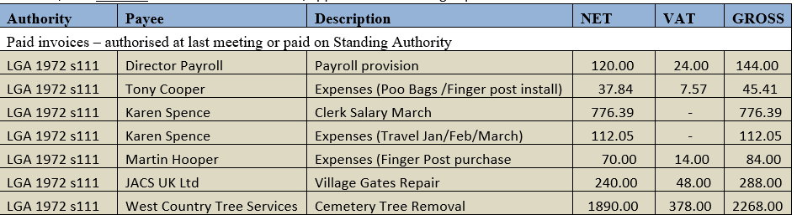
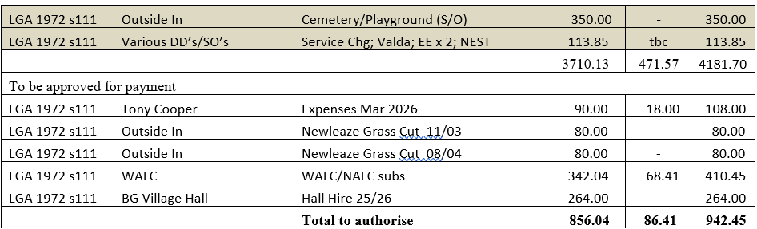

- Receipts: Council noted receipts of £1103.00 (Cemetery) for March 2026
- Account balances: – As at 31st March 2026
- The bank reconciliations for March were signed off by Councillor Griffiths.

PLANNING
2627/008. Planning:
- There were no planning applications received since the previous meeting for Council to consider.

(Please note in planning matters the Council acts as the consultee of the Principal Authority. The Principal Authority being the deciding body.)

- Clerk updated councillors about planning submissions for the property on The Common (issue raised by Cllr Healy at the previous meeting). Resolved: Councillors noted that the application for this development had been considered at a previous meeting and no objections raised. It was considered that the nature of the site and the situation of the structure in a limited space constitutes overdevelopment of that area. Resolved: Councillors agreed that they may need to revert to previous practice of conducting a site visit prior to the application being discussed at Council meeting. Resolved: To facilitate this Clerk will send out a link to applications as they are received so that Councillors can initiate a site visit if deemed necessary.
2627/009. Planning decisions:
Council noted the following planning decisions made since the last meeting.

MAINTENANCE

2627/010. Parish Steward:
Council noted that the Parish Steward was again unable to make a visit in April due to being diverted to other work. There are no scheduled visits in May as this is the time that Parish Stewards are all on ‘verge duties’.
26/011. Parish Steward:
Council discussed lists for Parish Steward and agreed that, as there is no certainty about when visits will recommence, there will be no benefit to submitting an additional list at this point. Resolved: If Steward contacts clerk, regular list should be suggested (with priority 1 being potholes) in addition to anything else he identifies.
Council noted that the next dates for the Parish Steward is scheduled to attend Broughton Gifford are 1st and 2nd June 2026.

2627/012. Village Maintenance Report (standing agenda item):
Council received a verbal report from Councillor Cooper considered the following items related to village maintenance:
- Millennium Pond – agreed that this does need some further pruning/attention. Resolved: Add to July agenda for action in Aug/Sept.
- Brambles around trees at top of common. Resolved: As above (Cllr Hooper will initially use hedge cutter and the rest to be cleared by hand).
- Flag pole safety inspection email: Cllr Cooper briefed on the inspection and clean he has undertaken. There is no sign of deterioration, ground fixings are good and lanyard still serviceable. Resolved: Clerk to advise supplier that we will not take them up on offer; Cllr Cooper to contact Atworth PC who have a pole from the same supplier.
- Cllr Cooper’s intention to take a sabbatical from the village caretaking/maintenance role was formally acknowledged. Resolved: Cllr Cooper will enlist the assistance of identified individuals who may help when required. Any larger jobs will be flagged to Council for possible outsourcing to a contractor.
- War Memorial triangle: Cllr Cooper and Cllr Parker (along with Cllr Parker’s husband) have undertaken a significant ‘tidy-up’ of this area.
- Sand bins: Sawmills Trading Estate bin hasn’t got any sandbags in and the one outside the Village Hall is covered in brambles. Resolved: Cllr Hooper will check if he has spare sandbags to replenish and Cllr Cooper will clear brambles.
- Newleaze Brook: Ongoing issue; brook needs clearing with a digger, landowners & householders not maintaining. Resolved: Cllr Cooper will visit to assess. Include in the Environmental Survey/Flood project.

and March
COMMONS/CEMETERY/FOOTPATHS
2627/013. Speed Indicator Device:
This is ongoing with no further update this month, awaiting decision reference the required highways improvements (currently scheduled for May 2026).

ADMINISTRATION

2627/014. Stone Barn (standing agenda item):
Council was advised that 1 quote had been received for the scaled down option but this is incomplete. Resolved: Cllr Griffiths will follow up and this will be revisited at the meeting in May.

2627/015. ACM Agenda:
Council reviewed and approved the draft agenda for the annual council meeting to be held immediately prior to the Full Council Meeting on Wednesday 13th May (7pm).

2627/016. AGAR Update – New Assertion 10 Requirements:
Council received an update from the clerk regarding progress on our internal audit and preparation for the Annual Governance and Accountability Return to the external auditor. In addition, Council reviewed and approved an IT Policy which is one of the requirements under the new Assertion 10 guidance. Resolved: IT Policy adopted and Clerk to provide additional information of Assertion 10 compliance at the May meeting.

2627/017. Friends of St Mary’s School – sponsored run on Common:
Council formally approved a request from Friends of St Mary’s School for the sponsored run on 24th April (as informally discussed and agreed at the meeting held on March 11th 2026).

2627/018. Defibrillator Training:
Council received a verbal update about Defibrillator Training booked for 18th May. Resolved: Cllr Cooper and Cllr Norris will distribute posters and promote the session.

2627/019. Items for Parish magazine & Notice Boards:
No additional items were identified for inclusion in magazine or on website/notice boards:

2627/020. Notice of items to be taken into consideration at the next meeting in February:
There were no additional items identified for inclusion on the agenda for the next meeting.

2627/021. Correspondence:
There were no items of correspondence (forwarded to all Councillors since the previous meeting) for councillors to note.

2627/022. Date of the next meeting:
Council is asked to note that the next meeting will be held on Wednesday 13th April 2026 at 7:30 pm in the village hall. This will be preceded by a meeting of the Annual Council Meeting which will commence at 7pm. All are welcome to attend.

With no further business, the meeting closed at 20:59 pm

