Minutes of the Ordinary Council Meeting of Broughton Gifford Parish Council held on
Wednesday 11th March 2026 in the Village Hall starting at 7:30pm

Present: Cllrs Hooper (Chair), Cooper, Corbin, Griffiths, Healy, Monk, Norris, Packer, Wright
Absent: Cllr Baker
In attendance: Karen Spence (Parish Clerk), and 2 members of the public.

Public Participation: One member of the public was present to talk about an existing planning proposal from 15/01/2023 PL/2022/03914 and seek council views about whether this application as no further progress appears to have been made. Resolved: Clerk to research this application and contact WC for further information. The second member of the public was present to provide information for the item at 2526/222 and discussion is minuted under this item.

Wiltshire Councillor Andrew Griffin was not present.

PRELIMINARIES

2526/207. Co-option of Councillor: Council was unable to consider co-option of a new counsellor to fill the one remaining vacancy as the individual who expressed an interest was not present at this meeting; this individual has advised by email that they would still like to be considered. Resolved: that co-option will be added to the March agenda to allow a further opportunity.

2526/208. Acceptance of apologies: Apologies were received from Cllrs Corbin, Baker and Packer

2526/209. Declarations of interest:
None received.
In accordance with the code of conduct when a councillor declares a non-pecuniary interest, they take no part in the discussion or vote. When a councillor declares a pecuniary interest, they are required to leave the room during discussion and voting.
2526/210. Dispensations: None received

2526/211. Exclusion of the Press and Public:
There were no items for which members of the press/public needed to be excluded.

PREVIOUS MEETING

2526/212. Previous meeting minutes:
Minutes of the meeting held on 11th February 2026 were formally agreed and signed as a correct record of the meeting and have since been posted onto the website.

No matters arising from the minutes were discussed during this meeting and will be reviewed at the April meeting:
- The Action log will be restructured and updated before review at next meeting
- There was no update available for Flood plan/environmental survey.

FINANCE
2526/213.
- Invoices: Council noted and approved the following expenditure

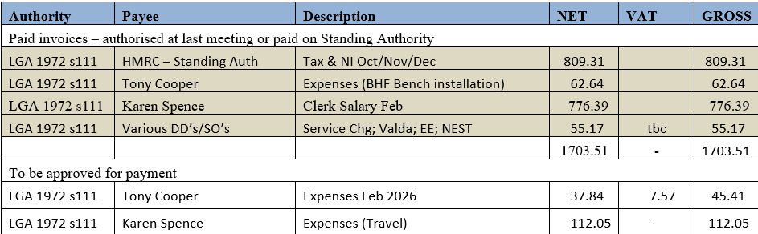
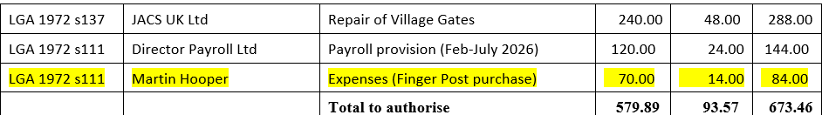

- Receipts: Council noted receipts of £2390.15 (CIL monies land at Fairview) for February 2026
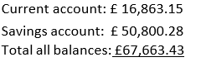
- Account balances: – As at 28th February 2026

- The bank reconciliations for February 2026 were signed off by Councillor Griffiths.

- Re-approval of Direct Debits/Standing Orders: Council reviewed and re-approved the following:
Monthly
- Valda (Stone Barn utilities)
- EE (mobile phone)
- NEST (clerk pension)
- Lloyds Bank (charges)
Annual/Other
- Information Commissioners Office
- Outside In (Monthly March-October only)

- Re-approval of Standing Authority (clerk) permissions: For Council to review and re-approve the following:
- HMRC
- Director Payroll Ltd (formerly Highland Payroll Services)
- Karen Spence (Salary and Working from Home Allowance)
- Water 2 Business (Stone Barn & cemetery)

PLANNING
2526/214. Planning:
- Council reviewed and considered the following planning applications received since the previous meeting.
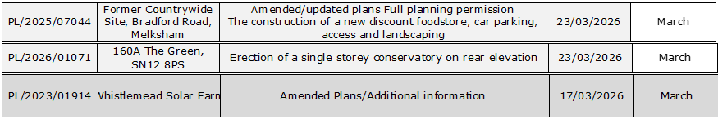

Resolved: There were no objections to the application PL/2026/01071. Council considered that the amended plans for both the Aldi/former Countrywide site and Whistlemead Solar Farm did not address the objections raised to the original applications. Resolved: Clerk to submit further comments on both of these applications utilising wording provided.
(Please note in planning matters the Council acts as the consultee of the Principal Authority. The Principal Authority being the deciding body.)

- During the planning discussions concern was raised by Cllr Healy regarding some ongoing development of a structure being built in the grounds of a property on The Common. Resolved: Clerk to check the position re planning application and to contact Wiltshire Council.
2526/215. Planning decisions:
Council noted the following planning decisions made since the last meeting. Council were briefed by the clerk that PL/2026/0028 had not been reviewed as notification had not been received about this application. Resolved: Counsellors reviewed the submission documents and agreed that they would not have objected had they seen it prior to approval.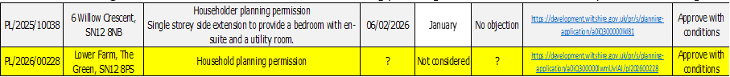

MAINTENANCE

2526/216. Parish Steward:
Council noted that the Parish Steward was again unable to make a visit in March due to being diverted to other work.
2526/217. Parish Steward:
Council discussed lists for Parish Steward and agreed that, as there is no certainty about when visits will recommence, there will be no benefit to submitting an additional list at this point. Resolved: If Steward contacts clerk, regular list should be suggested (with priority 1 being potholes) in addition to anything else he identifies.
Council noted that the next dates for the Parish Steward is scheduled to attend Broughton Gifford are 1st and 2nd April 2026.

2526/218. Village Maintenance Report (standing agenda item):
Council received a verbal report from Councillor Cooper considered the following items related to village maintenance:
- Play Area maintenance/repair to ‘clatter bridge’ – quote from original suppliers of £90 for replacement of 1 tread. Resolved: Councillors approved purchase and Cllr Cooper will fit.
- Damage to War Memorial Triangle. Resolved: Councillor Hooper will assess and have a conversation with the builders working in the vicinity.
- Cemetery Willow – update re felling and information on options for replacement tree. It was drawn to Councils attention that the felling had left the surrounding area in need of some tidying and re-seeding etc. Resolved: Councillor Hooper/Cooper to conduct a site visit and consider actions required to return the area to acceptable condition. A replacement tree will be planted in the Autumn and Cllr Cooper will research options. me.
- Newleaze Grass cutting for forthcoming year. Resolved: Outside In will take over the cutting of this area as and when needed (unless it is too wet) at a cost of £80 per cut for the forthcoming year. This will be invoiced separately from the main contract for Play area and cemetery.

and March
COMMONS/CEMETERY/FOOTPATHS
2526/219. Speed Indicator Device:
This is ongoing with no further update this month, awaiting decision reference the required highways improvements. Clerk advised that, due to changes in the frequency of LHFIG meetings this will not now be considered until May 2026.

2526/220. Parking Issues around The Common:
Council considered an email from a member of the public regarding parking on The Common. Resolved: That double yellow lines were not appropriate at this point. Cllr Cooper will write an item for the village magazine to remind re considerate parking.

2526/221. Cemetery:
Council reviewed cemetery charges for 2026/27 and to consider a verbal report from the clerk regarding advance purchase of plots. Resolved: That all cemetery charges would be increased by 5% and that the subject of advance purchase of plots be brought back to a future meeting to enable more time to be given to a broader discussion.

ADMINISTRATION

2526/222. Stone Barn (standing agenda item):
Council heard representation about initial findings re available funding from Crispin Shingler (full report to be provided at a later date. Council was advised that there are many sources of funding for which we could meet the criteria for although the view was that we would be more likely to be successful for the most recent, scaled back option. Resolved: After much discussion majority decision was to pursue Option B (scaled back version of plans) but making sure that the specification included the required kitchen facilities and cold running water and the following actions were agreed:
- Crispin Shingler will produce a briefing to consolidate the most likely options and what would have to be included to meet the criteria for each.
- Cllr Griffiths to obtain fixed price quotes for Option B
- Clerk to update the planning authorities that work has commenced (drainage, remedial and clearance work plus some exterior work to address access issues).

2526/223. Meeting dates and APM agenda
Council:
- Reviewed and approve the draft agenda for the annual parish meeting to be held on Monday 13th April. Resolved: Clerk to send out invites
- Agreed that the Annual Council Meeting will be held on Wednesday 13th May at 7pm (immediately prior to the Full Council Meeting.
- Agree that, for the remainder of 2026 Full Council meetings will continue to be held on the second Wednesday of each month (except for August when there is no meeting).

2526/224. Great British Spring Clean
Council reviewed arrangements and agreed no further action required. Clerk advised that the rubbish bag collection had been booked with IdVerde.

2526/225. Items for Parish magazine & Notice Boards:
No additional items were identified for inclusion in magazine or on website/notice boards:

2526/226. Notice of items to be taken into consideration at the next meeting in February:
The following items were requested for inclusion on the agenda for the next meeting.
- Formal approval for request from Friends of St Mary’s School to hold a sponsored walk on the Common (NB: This was informally approved at this meeting and clerk requested to notify the Friends).
- Formal acknowledgment of Cllr Coopers intention to take a sabbatical from the village caretaking/maintenance role and discussion around how to manage this going forward.

2526/227. Correspondence:
Councillors noted and acknowledged the following item of correspondence forwarded to all Councillors since the previous meeting.

2526/228. Date of the next meeting:
Council is asked to note that the next meeting will be held on Wednesday 8th April 2026 at 7:30 pm in the village hall. This will be preceded by a meeting of the Finance Committee at 7pm. All are welcome to attend the main meeting.

With no further business, the meeting closed at 21:12 pm

