Minutes of the Ordinary Council Meeting of Broughton Gifford Parish Council held on
Wednesday 14th January 2026 in the Village Hall starting at 7:30pm

Present: Cllrs Hooper (Chair), Baker, Cooper, Corbin, Griffiths, Healy, Monk, Norris, Wright
Absent: Cllrs Healy and Packer
In attendance: Karen Spence (Parish Clerk), Cllr Griffin (Wiltshire Council) and 1 member of the public.

Public Participation: The Chair invited one member of the public to speak in respect of creating a village podcast under the umbrella of a community interest company. Councillors were generally supportive in principle and the member of the public (who is also interested in co-option to the final unfilled councillor role) will bring further information to a future meeting. Resolved: Council will offer a final opportunity for co-option at its meeting in February and will advertise this to ensure any other interested parties also have opportunity.

Wiltshire Councillor Andrew Griffin gave an update on the footpath in the village which is currently blocked. Council staff are currently observing a short intentional wait period prior to legal action being instigated.

PRELIMINARIES

2526/164. Acceptance of apologies: Apologies were received from Cllrs Healy and Packer

2526/165. Declarations of interest:
None received.
In accordance with the code of conduct when a councillor declares a non-pecuniary interest, they take no part in the discussion or vote. When a councillor declares a pecuniary interest, they are required to leave the room during discussion and voting.
2526/166. Dispensations: None received

2526/167. Exclusion of the Press and Public:
There were no items for which members of the press/public needed to be excluded.

PREVIOUS MEETING

2526/168. Previous meeting minutes:
Minutes of the meeting held on 14th December 2025 were formally agreed and signed as a correct record of the meeting and have since been posted onto the website.

The following matters arising from the minutes were discussed:
- Review of Action log - Clerk to email council again advising that traffic calming on Common is dangerous and repairs need to be a priority. Also, a further Highways Improvement Form to request priority signage.
- Village Gates – contractor intends to try and re-install by end of month
- Blocked footpath – see above
- Cemetery tree – Quote obtained
- Bus Shelter - ongoing
- BHF In Living Memory bench – Location to be Newleaze on grass other side from telephone box

FINANCE
2526/169.
- Invoices: Council noted and approved the following expenditure and the clerk passed on from the Friendship Club for the grant award:
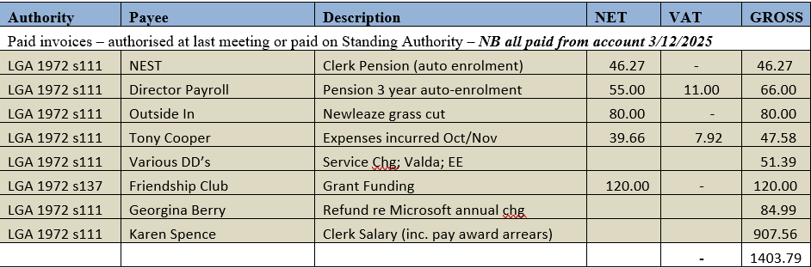
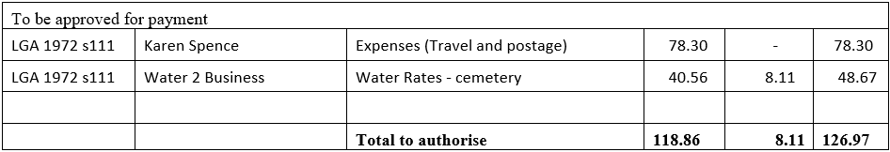

- Receipts: There were on receipts for Council to note for December 2025.
- Account balances: – As at 31st December 2025

- The bank reconciliations for December 2025 were signed off by Councillor Griffiths.

PLANNING
2526/170. Planning:
- Council reviewed and considered the following planning application received since the previous meeting.

Resolved: There were no objections to this application.
(Please note in planning matters the Council acts as the consultee of the Principal Authority. The Principal Authority being the deciding body.)

- Council considered 2 emails relating to Lime Down Solar Park and the proposed Aldi Development. Resolved: Council approved the clerks (already submitted) comment for the Aldi proposal and Clerk to register on the portal for Lime Down prior to 9th January in order that a comment can be submitted if required.
2526/171. Planning decisions:
There were no planning decisions made since the last meeting for Council to consider.

MAINTENANCE

2526/172. Parish Steward:
Council noted that the Parish Steward was again unable to make a visit in January to being diverted to other work. As further information on this Council noted an email from Wiltshire Council advising that stewards had been diverted.
2526/173. Parish Steward:
Council considered a list for the next visit scheduled for February 2025. Resolved: Clerk to request that, assuming normal visit schedule is restored in February, normal list plus those items highlighted in December are undertaken.
Council noted that the next dates for the Parish Steward to attend Broughton Gifford are 2nd and 3rd February 2026.

2526/174. Village Maintenance Report (standing agenda item):
Council considered a verbal report provided by Councillor Cooper:
- Cemetery Willow – A quote for £1800 had been received for removal and stump grinding. Councillor Cooper has sought additional quotes but has been unable to get any response so for additional quotes as at the date of this meeting. Resolved: Clerk to check with WC re whether there is any Tree Preservation order on this. Due to the proximity of nesting season and inability to obtain additional quotes, Council resolved that this quote should be accepted
NB – In the intervening period an additional quote has been received and this matter will thus be brought back to next meeting for ratification.

- Norrington Gate Finger Post – a quote for £70 exc. VAT (assuming it is collected by someone) had been received. Resolved: Council approved this expenditure. Cllr Cooper will pay and claim this back on expenses. Councillors Cooper/Hooper to liaise reference collection.

- A date was discussed for the Great British Spring Clean in the village. Resolved: This will be held on Sunday 22nd March 2026.

and March
COMMONS/CEMETERY/FOOTPATHS
2526/175. Speed Indicator Device:
This is ongoing with no further update this month, awaiting decision reference the required highways improvements.

ADMINISTRATION

2526/176. Review of Policies and Procedures (Standing Orders):
Updated Standing Orders (including NALC 2025 updates) were reviewed and approved. Resolved: Clerk to circulate and upload onto the website. NB: The Internal Auditor has since highlighted that there is a discrepancy between the updated Standing Orders & Financial Regs as follows:
- the former record a value of £60,000 for formal tender action, whilst the latter record a value of £10,000 including VAT (Paras 18.a.v and 5.6 in the respective documents. A consistent value should be recorded, ideally at £10,000 excluding VAT.
This matter will be raised and resolved at the February meeting.

2526/177. Finance, Budget & Precept Setting:
Council received an update from the Clerk following the budget meeting held earlier the same evening and noted/approved the following:
- noted an update on spend against budget for the current financial year – budgets had not been formally agreed for the current and previous financial years and thus are not as useful in monitoring spend as they should be.
- Council reviewed budgets and agreed that new levels be set to more accurately reflect increase in costs: Resolved: Clerk to amend budgets for 2026/27 to reflect levels agreed at the earlier Finance Meeting.
- Precept: Council noted figures prepared by Clerk based on a 5% increase over the current year (utilising Wiltshire Council Precept calculator tool). Resolved: Council resolved to set Precept requirement at £20,233.69 for 2026/27 and the Precept Requirement From was signed off by the Clerk and The Chai. Clerk to submit form to Wiltshire Council prior to the deadline date 20/01/2026.

2526/178. Clerk contract and working arrangements:
The Appendix the Clerks contract which details revised hours, salary and allowances (approved at previous meeting) was signed off by the Clerk and the Chair.

2526/179. Stone Barn (standing agenda item):
Council received an update from Councillor Griffiths and Councillor Hooper. New plans have been drawn up by the original architect to enable the building to solely be made sound. Cllr Hooper advised that he has had further discussion about accessing potential external funding to enable BGPC to stick to the original plan and a meeting will take place to explore this further. Resolved: Cllr Hooper to bring details of his discussion back to the February meeting where a decision can then be made about the way forward. NB As we put this out for tender in the first instance, it will be necessary to offer all previous tender applicants to quote again based depending on which approach is agreed.

2526/180. Flood Prevention Survey/Advice:
Council received an update from Cllr Corbin regarding work she has been doing with Renate Malton at Wiltshire Council. As part of this Cllr Corbin presented a draft Flood Plan which she would like views on. Council also discussed the opportunity to work with Wiltshire Wildlife Fund who can produce as Environmental Flooding Survey which will help in identifying possible mitigation measures. This would be partly funded by Wiltshire Council. This suggestion was met with enthusiasm and The Chair requested that Councillor Corbin raised the following motion:
Motion: That Council approve funding to allow an environmental flood survey and allocate budget for this in 2026/27; seconded Cllr Hooper. Resolved: Motion approved unanimously.

2526/181. Items for Parish magazine & Notice Boards:
The following additional item was identified for inclusion in magazine or on website/notice boards:
- Councillor Cooper to include a brief item about the BHF red bench with a note that further information will follow

2526/182. Notice of items to be taken into consideration at the next meeting in February:
The following items were requested for inclusion on the agenda for the next meeting.
- Cllr Monk to submit a motion for a donation from the parish to enable a disco to be run for village teenagers around Christmas 2026. (This would be a collaboration with the village hall and some Councillors would be involved in the planning).
- Bus Shelter

2526/183. Correspondence:
There were no items of correspondence forwarded to all Councillors since the previous meeting.

2526/184. Date of the next meeting:
Council noted that the next meeting will be held on Wednesday 11th February at 7:30 pm in the village hall. All are welcome to attend. (There will be a Finance Committee meeting immediately prior to this at 7pm)

With no further business, the meeting closed at 20:55 pm

