Minutes of the Ordinary Council Meeting of Broughton Gifford Parish Council held on
Monday 15th September 2025 in the Village Hall starting at 7:30pm

Present: Cllrs Hooper (Chair), Cooper, Griffith, Monk, Norris, Packer
Absent: Cllrs Corbin, Fielding, and Wright
In attendance: Karen Spence, Parish Clerk, Andrew Griffin (Wiltshire Councillor) and 3 members of the public.

Public Participation: The Chair invited two members of the public to speak in respect of one element of the Cemetery item (2526/081 – discussion and resolution recorded at that point in the minutes).

PRELIMINARIES

2526/070 Acceptance of apologies: Apologies were received from Cllrs Corbin, Fielding & Wright.

2526/071. Declarations of interest:
None received.
In accordance with the code of conduct when a councillor declares a non-pecuniary interest, they take no part in the discussion or vote. When a councillor declares a pecuniary interest, they are required to leave the room during discussion and voting.
2526/072. Dispensations: None received

2526/073. Exclusion of the Press and Public:
There were no items for which members of the press/public needed to be excluded.

PREVIOUS MEETING

2526/074. Previous meeting minutes:
Minutes of the meeting held on 9th July 2025 were formally agreed and signed as a correct record of the meeting and have since been posted onto the website (NB there was no meeting in August 2025).

The following matters arising from the minutes were discussed:
- Review of Action log
- Laptop/operating system – to be raised again at next meeting
- Newleaze Grass Cutting – Resolved: To continue with Outside In until the Spring and then review again
- Update re Aldi proposed development (invite to Melksham TC meeting)

FINANCE
2526/075.
- Invoices: Council noted and approved the following expenditure 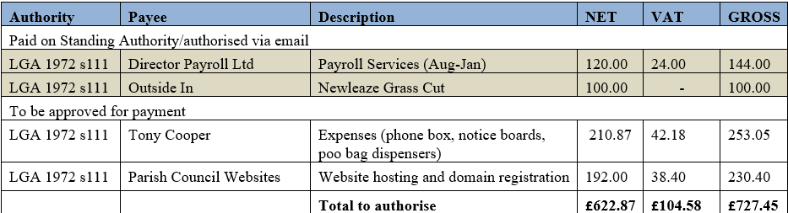

- Receipts: There were no receipts for Council to note for August 2025.
- Account balances: – As at 31st July 2025
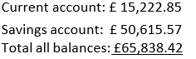
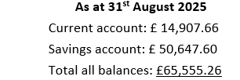
- Councillor Griffiths signed off the bank reconciliations for July and August 2025.

PLANNING
2526/076. Planning:
- Council considered the following planning applications which had been received since the previous meeting:

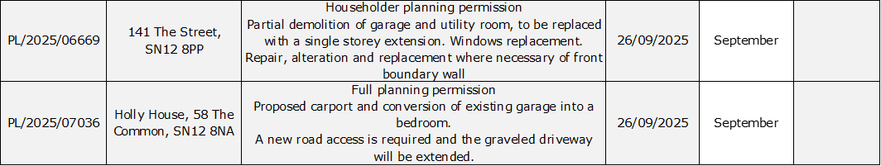

Resolved: There were no objections to any of either of these applications
(Please note in planning matters the Council acts as the consultee of the Principal Authority. The Principal Authority being the deciding body.)

- Council noted response reference PL/2021/08690 and PL/2025/02594 (Land at Studley Farm) which was discussed at July meeting.

2526/077. Planning decisions:
Council noted the following planning decisions made in the period since the previous meeting and agreed that there were no material differences to the revised plans submitted for PL/2025/04726 and therefore their previous ‘no objection’ stands.
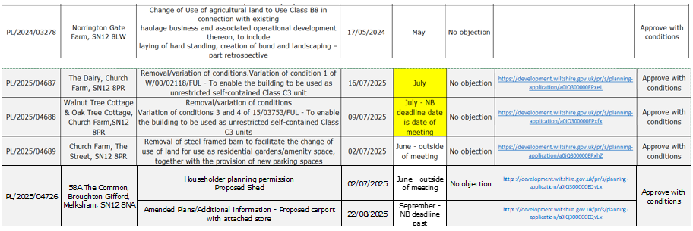

MAINTENANCE

2526/078. Parish Steward:
Council noted the list of completed works carried out by the Parish Steward on the September visit.
2526/079. Parish Steward:
Council considered a list for the next visit scheduled for October 2025. Resolved: Clerk to request that, in addition to the usual list, the Parish Steward undertakes a check of the drains with particular attention to the drain outside Townsends Garage.
The Parish Steward can only complete works listed in appendix 1. (Page 6)
Council noted that the next dates for the Parish Steward to attend Broughton Gifford are 1st and 2nd October 2025.

2526/080. Village Maintenance Report (standing agenda item):
Council received a report and a verbal update from Councillor Cooper:
- Cemetery Willow – this is in bad condition with a broken branch and splitting. Resolved: The tree needs to be removed, Councillor Cooper to obtain a quote from Tim Hipkin
- Brambles on the Common – Resolved: Councillor Hooper to assess with a view to cutting back
- Millenium Pond is overgrown again. This is an ongoing issue to be returned to a future meeting
- Dead tree on common – Resolved: Councillor Cooper to clear
- Norrington Common phonebox – still requires leaflets. Resolved: Clerk to source through TIC in Melksham.

COMMONS/CEMETERY/FOOTPATHS
2526/081. Speed Indicator Device:
Councillor Monk gave a further update. It was agreed that the Council wish, at this time to purchase a single device and that it should be movable. This will require something different in terms of installation (Council were advised that Atworth went for a locking flap for which they were charged circa £650 by Wiltshire Council highways. Resolved: Cllr Monk to arrange for Wiltshire Police expert to come out and advise re positioning. Clerk to contact Wiltshire Council re restrictions on positioning etc (NB Wiltshire Council have since advised that, once we have decided on position this will have to go through LHFIG Highways Improvements process for authorisation and costing for the installation mechanism prior to installation).
2526/082. Cemetery:
The clerk gave a verbal update regarding issues highlighted at the previous meeting. Two representatives of the family of one deceased couple (whose ashes have recently been interred in the cemetery) were present to discuss the issue of the memorial. They acknowledged that they had received the memorial regulations and that the proposed memorial will now be altered to meet these. Council also considered an email from the MOD regarding the replacement of a damaged headstone which MOD will replace at their cost: Resolved: Clerk to notify MOD that approval is given for this.
NB: Given the lack of remaining space in the cemetery, it is suggested that (at a future meeting) Council consider ceasing the sale of advance purchase plots (EROB’s). This would have to be done from a future date to give sufficient notice to parishioners that this will not be offered going forward.

ADMINISTRATION

2526/083. Review of Policies and Procedures (Financial Regulations and Standing Orders):
Council considered a draft of revised Financial regulations and were briefed by the Clerk on various prescribed content which would require a change of process or were not practically possible for a small Parish Council. Resolved: The Clerk will contact our internal auditor to seek advice on these items. Financial Regulations were provisionally approved subject to incorporation of any feedback/advice from internal auditor. Standing Orders review was deferred to the October meeting.

2526/084. Committees and Representatives:
This item was deferred until the October meeting.
2526/085. Clerk contract and working arrangements:
Council received a verbal update from the clerk in which she advised of her upcoming move away from the immediate area. The clerk is prepared to continue in post but this would involve some changes in how the day-to-day work is managed (particularly around postal collection and posting of documents on noticeboard). Resolved: Council would like the clerk to continue in post and clerk will submit a brief report to the October meeting suggesting how this might work. Both the clerk and the council will keep the new arrangements under review to ensure that things are working effectively for both parties.

2526/086. Grant Requests:
Council considered and approved the following grant requests:
- an informal request from the Village Hall Committee in respect of a contribution to the cost of the kitchen refurbishment.
- A request from a member of the public with reference to the printing of historical commemoration books
Resolved: That the above requests are approved and for the clerk to arrange payment of £500 and £187.63 respectively. Councillors resolved that neither of these requests required the clerk to obtain a formal grant application form.

2526/087. Stone Barn (standing agenda item):
There has been no further progress on identifying grant funding for this project. Councillors briefed Wiltshire Councillor Griffin on the difficulties which have been encountered. Resolved: Cllr Griffin to send details to Clerk about new Community Hub initiative being introduced by Wiltshire Council.

2526/088. Items for Parish magazine & Notice Boards:
Councillors were asked to highlight additional items for the clerk to include in magazine or on website/notice boards. Resolved: Clerk to place a notice on the website of the intention to co-opt to 2 remaining councillor vacancies at the October/November meeting.

2526/089. Notice of items to be taken into consideration at the next meeting in October:
Councillors requested that the condition of the drainage ditch at the back of Newleaze be included as an agenda for the next meeting.
In addition, council discussed the following:
- SSEN offer to come and deliver a 15-minute slot at an ordinary Council meeting
- Defibrillator training (1hr) – to be delivered outside of a meeting
Resolved: Clerk to contact the proposers of both and arrange for these to take place

2526/090. Correspondence:

- There were no items of correspondence forwarded to all Councillors since the previous meeting. There were no emails forwarded to all Councillors for Council to note and acknowledge since the previous meeting.
- Council reviewed an email from the Kingston Group alongside the Clerks response and discussed whether this response was in line with Councillors views. Resolved: Councillors agreed with the response to this request as issued by the Clerk

2526/091. Date of the next meeting:
Council noted that the next meeting will be held on Wednesday 8th October at 7:30 pm in the village hall. All are welcome to attend.

With no further business, the meeting closed at 21:35 pm

