**Minutes of the Ordinary Council Meeting of Broughton Gifford Parish Council held on**

**Monday 15th September 2025 in the Village Hall starting at 7:30pm**

**Present:** Cllrs Hooper (Chair), Cooper, Corbin, Fielding, Griffith, Monk, Wright

**Absent:** None

**In attendance:** Karen Spence, Parish Clerk and 3 members of the public.

**Public Participation:** The Chair invited one member of the public to speak in respect of the Norrington Common phone box (Agenda item 2526/060 – discussion and resolution recorded at that point in the minutes). The 2 remaining members of the public were in attendance in respect of the co-option of councillors and details are recorded at Agenda item 2526/045 below.

**PRELIMINARIES**

2526/045. **Co-option of Councillors:**

1. Council received representation from Mrs Sheila Packer and Mr Barry Norris detailing verbal applications from to fill 2 of the vacancies left following the election on 1st May 2025. ***Resolved:*** *Considered and approved. Declarations and Acceptance of Office were signed by both new councillors who then sat for the remainder of this meeting. Clerk to complete registrations with Wiltshire Council and, in due course, to produce an induction pack for the newly co-opted councillors.*
2. Councillors absent at the meeting held on 14th May 2025 to sign acceptance of office.

2526/046 **Acceptance of apologies:** There were no absences.

2526/047. **Declarations of interest:**

Councillor Martin Hooper declared an interest in 2 of the planning applications under item 2526/052. ***Resolved****: As this is potentially pecuniary it was agreed that Councillor Hooper would leave the room for whilst these 2 applications are discussed.*

*In accordance with the code of conduct when a councillor declares a non-pecuniary interest, they take no part in the discussion or vote. When a councillor declares a pecuniary interest, they are required to leave the room during discussion and voting.*

2526/048. **Dispensations:** None received

2526/049. **Exclusion of the Press and Public:**

There were no items for which members of the press/public needed to be excluded.

**PREVIOUS MEETING**

2526/050**. Previous meeting minutes:**

Minutes of the meeting held on 14th May 2025 were formally agreed and signed as a correct record of the meeting and have since been posted onto the website (NB there was no meeting in June 2025).

**FINANCE**

2526/051.

1. **Invoices:** Council noted and approved the following expenditure



1. **Receipts:** There were no receipts for Council to note for May 2025. Council noted receipts of £1358 for June 2025 (closed churchyard grant)
2. **Account balances**: – **As at 31st May 2025**

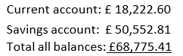

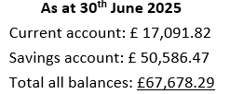

1. Councillor Griffiths signed off the bank reconciliations for April, May and June 2025.

**PLANNING**

2526/052. **Planning**:

1. Council considered the following planning applications which had been received since the previous meeting:

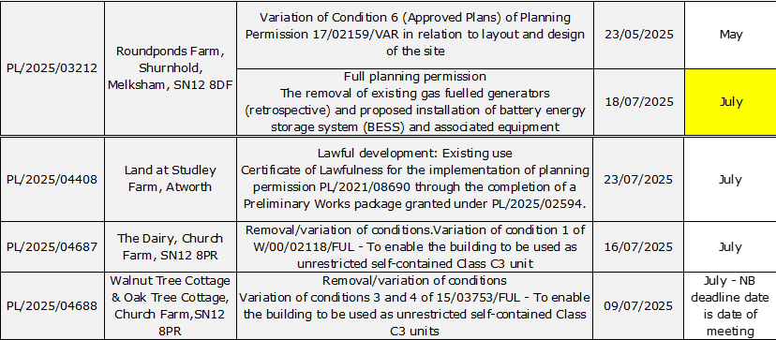

***Resolved:*** *There were no objections to any of these applications* (NB: Councillor Hooper left the meeting during discussion on the final 2 in which he has declared an interest)

(Please note in planning matters the Council acts as the consultee of the Principal Authority. The Principal Authority being the deciding body.)

1. Council additionally noted decisions made outside of a meeting due to cancellation of the meeting due to be held on Wednesday 11th June.

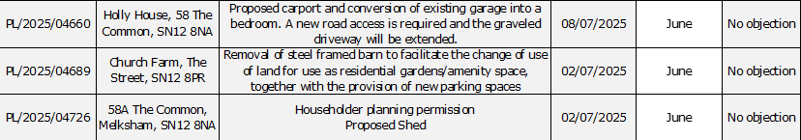

1. Council asked to consider (pre-planning) consultation on proposed new location for the Aldi Store in Melksham (former Countrywide site) ***Resolved:*** *No substantial concerns were raised at the present time although it was felt that this may present some issues with traffic exiting onto the Farmers Roundabout.*

2526/053. **Planning decisions:**

Council noted the following planning decisions made in the period since the previous meeting:



**MAINTENANCE**

2526/054. **Parish Steward:**

1. Council noted that the scheduled visit for June did not take place due to Parish Stewards annual leave. However, the steward did undertake an unplanned visit prior to his leave and carried out “all the usual tasks” plus the following:

* cut the bank on the pavement by the school
* pressure washed village gates on Coombe Lane the bollards and paved area on the common

1. Council noted the list of works carried out on the July visit

2526/055. **Parish Steward:**

As there is no scheduled Parish Steward visit for August, Council considered a list for the next visit scheduled for September 2025. ***Resolved:*** *Clerk to request that the usual list of regular works be undertake and also to highlight the appearance of a lump in the pavement outside Holly Brook House with a view to finding out who might be able to rectify this assuming it is not the Parish Steward..*

The Parish Steward can only complete works listed in appendix 1. (Page 6)

*To note: the next dates for the Parish Steward to attend Broughton Gifford are 1st and 2nd September 2025.*

2526/056. **Village Maintenance Report (standing agenda item):**

Council received a report and a verbal update from Councillor Cooper:

* Play Area – Brambles – Councillor Cooper will clear; Directional signage for playpark now installed on Curtis Orchard signs: ongoing issues re emptying of bins. Clerk to follow up
* Bench’s– Plaque has now been installed on poppy bench and repair has been made to broken slats on ‘Hiscock’s’ bench. Cheque for cost of poppy bench has now been passed to clerk for depositing.
* Norrington Common phonebox – see agenda item 2526/060 below.
* Dogs: Poo bag dispensers replenished following information from a parishioner, one ‘clean up after your dog’ sign re-installed; it was identified that there is a broken dispenser adjacent to Oughton’s wall (Cllr Cooper will assess).
* Finger Post - Councillor Cooper to forward details to Clerk to enable obtaining of relevant documentation.
* Village Gates – Ongoing (***Previously Resolved:*** *Clerk to try and contact original supplier to enquire about possibility of repair (these gates were installed approximately 3 years ago and came through a Wiltshire Council approved site and were fitted by the unitary authority).*
* Newleaze grass cutting – Scaffolding means that it is not currently possible to access with a mower. Cllr Corbin will assess and try to establish when this will be removed. Dave Bull (Outside In) to be approached about whether he can undertake the task.

**COMMONS/CEMETERY/FOOTPATHS**

2526/057. **Speed Indicator Device:**

Councillor Monk gave an update following further research on the SID’s. This has now been narrowed down to 2 options one of is considerably more expensive than the other. ***Resolved:*** *That, provided there is no significant benefit from the more expensive version, the cheaper option should be progressed and that only one should be purchased initially. Clerk to enquire with Wiltshire Council Highways to confirm whether there are any restrictions on installation (distance from the highway etc).*

2526/058. **Cemetery:**

The clerk gave a verbal update which covered issues which have recently arisen with regard to the cemetery, particularly around locating of plots and failure to notify the Clerk (in her role as Cemetery Manager) of forthcoming burials. It was not deemed appropriate or practical for plots to be marked at the time of purchase of an EROB as had been suggested by a correspondent. ***Resolved:***

* *Clerk to investigate the situation regarding 2 memorials (currently being produced by PM Bines) which had been brought to the attention of the chair and were not deemed to comply with BGPC Memorial regulations.*
* *Clerk to contact all local Funeral Directors and Stonemasons to remind them of protocol/procedure when they are arranging a funeral which involves a burial in BGPC cemetery.*
* *Clerk to produce a notice for display on the Cemetery notice board and the webpage to highlight that the Clerk should be contacted in all cases to agree dates for burials and to ensure that the plot is located and identified prior to any service being planned.*

NB: Given the lack of remaining space in the cemetery, it is suggested that (at a future meeting) Council give consideration to ceasing the sale of advance purchase plots (EROB’s). This would have to be done from a future date to give sufficient notice to parishioners that this will not be offered going forward.

**ADMINISTRATION**

2526/059. **Review of Policies and Procedures (Financial Regulations and Standing Orders):**

It was agreed to defer this item to the September meeting.

2526/060. **Norrington Common Telephone Box:**

Following representation by email and during the Public Participation session of this meeting, council considered suggestions to ensure people are more aware of the phone box. Whilst some of the suggestions were considered either impractical or unnecessary the Council welcomed some of the initiatives suggested to ensure this becomes a useful point for local. ***Resolved****: That ‘Information Point’ signs be sourced and purchased to replace the original ‘Telephone Box’ signs; That a ‘back board’ containing slots for information leaflets be built and fixed – up to £250 approved for these 2 improvements. The clerk will approach Melksham Tourist Information office to enquire about availability and supply of leaflets.*

2526/061. **Highways Improvement Decision – Williams Mead:**

Council received an update from the on the LHFIG decision relating to the work which is waiting to be scheduled for completion by Wiltshire Council Highways. Once this is complete, BGPC will receive an invoice for the total amount of the PC contribution and the clerk will produce invoices for the residents’ contribution to the overall amount.

2526/062. **Stone Barn (standing agenda item):**

There was nothing to update on progress towards obtaining grants for the refurbishment of the Stone Barn, clerk has (as yet) been unable to allocate time to researching Lottery Heritage Fund.

2526/063. **Laptop/Operating System software:**

Council received a verbal update from the clerk regarding the potential incompatibility of the current laptop for upgrade to Windows11. ***Resolved:*** *Clerk to conduct further research into this and look at options for the purchase of an updated laptop if required.*

2526/064. **Items for Parish magazine & Notice Boards:**

There were no additional items highlighted.

2526/065. **Notice of items to be taken into consideration at the next meeting in June:**

The following items were identified by the clerk for inclusion on the next agenda:

* Review of Policies and Procedures deferred from 2526/059 above
* Consideration of ceasing the sale of advance purchase cemetery plots
* Committees and representatives
* There were no further items highlighted by Councillors.

2526/066. **Correspondence:**

Council to noted and acknowledge the following emails which have been forwarded to all Councillors since the previous meeting.

  

2526/067. **Dates of Meetings for 2025/26:**

Council noted the meeting dates for 2025/26 and considered a request from the clerk to change the date of the September meeting. Resolved: Change of date was not approved due to lack of availability on other September dates.

2526/068**. Committees and Representatives**:

Following the local elections, Council is asked to review representation to enable updating and re-publication of the list. **– This item was deferred to the next meeting.**

2526/069. **Date of the next meeting:**

As there is no August meeting, Council noted that the next meeting will be held on Wednesday 10th September at 7:30 pm in the village hall. All are welcome to attend.

With no further business, the meeting closed at 21:20pm