**Minutes of the Ordinary Council Meeting of Broughton Gifford Parish Council held on**

**Wednesday 14h May 2025 in the Village Hall starting at 7:30pm**

**Present:** Cllrs Hooper (Chair), Cooper, Fielding and Monk

**Absent:** Cllrs Corbin, Griffiths and Wright.

**In attendance:** Karen Spence, Parish Clerk and 1 member of the public.

**Public Participation:** The Chair invited one member of the public to speak in respect of Whistlemead Solar Farm. village maintenance: ***Resolved:*** *The clerk will submit a further objection to this application based on the various reports supplied and a previous email from the member of the public concerned.*

**PRELIMINARIES**

2526/022. **Acceptance of apologies:** Cllrs Corbin, Griffiths and Wright.

2526/023. **Declarations of interest:**

There were no declarations of interest.

*In accordance with the code of conduct when a councillor declares a non-pecuniary interest, they take no part in the discussion or vote. When a councillor declares a pecuniary interest, they are required to leave the room during discussion and voting.*

2526/024. **Dispensations:** None received

2526/025. **Exclusion of the Press and Public:**

There were no items for which members of the press/public needed to be excluded.

**PREVIOUS MEETING**

2526/026**. Previous meeting minutes:**

Minutes of the meeting held on 9th April 2025 were formally agreed and signed as a correct record of the meeting and have since been posted onto the website.

**Matters arising:**

* **Election - 1st May: Update given by clerk**
* **Waste Bins (Clerk) (deferred)**
* **Review of Action log (deferred)**

**FINANCE**

2526/027.

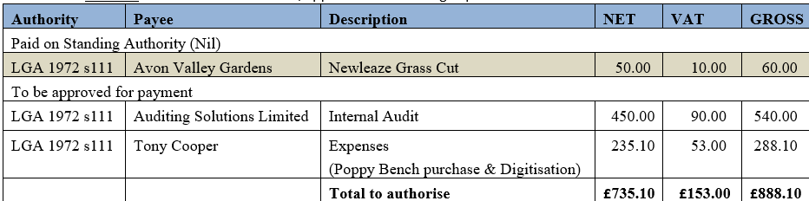

1. **Invoices:** Council noted and agreed expenditure on invoices (as shown above) totalling £888.10
2. **Receipts:** Council noted receipts of £9707.93 for April 2025 (Cemetery £150, Precept ½ 9557.93).
3. **Account balances**: – As at 30th April 2025

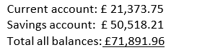

1. Councillor Griffiths was not present at this meeting; bank reconciliations will be signed off in June.

2526/028. **Internal Audit 2025:**

Council received and noted the 2025 Internal Audit. Resolved: Actions were agreed in principle and implementation will be discussed at a future meeting.

2526/029. **Year-end finance:**

Council approved and signed the year end accounts for the year ended 31/03/2025.

2526/030. **Annual Governance and Accountability Report (AGAR):**

a. Council approved and signed off Section 1 of the AGAR

b. Council approved and signed off Section 2 of the AGAR

**PLANNING**

2526/031 **Planning**:

1. Council considered the following planning applications which had been received since the previous meeting:

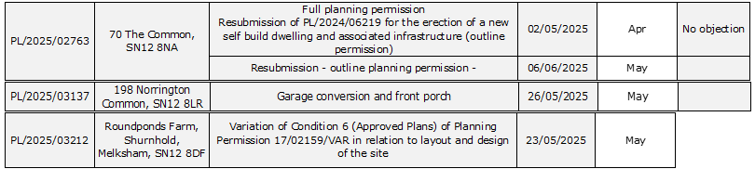

There were no objections to any of these applications.

(Please note in planning matters the Council acts as the consultee of the Principal Authority. The Principal Authority being the deciding body.)

1. Council additionally considered amended plans and communications in relation to PL/2023/01914 Whistlemead Solar Farm (see note under public participation above).

2526/032**. Planning decisions:**

Council noted the following planning decisions made in the period since the previous meeting:



**MAINTENANCE**

2526/033. **Parish Steward:**

As there was no visit during May 2025 there is no list of completed works for Council to note.

2526/034. **Parish Steward:**

Council considered a list for the next Parish Steward visit scheduled for June 2025. ***Resolved:*** *Clerk to request cleaning of village gates and to enquire with PS/Highways team re overgrown vegetation at the Challeymead junction.*

The Parish Steward can only complete works listed in appendix 1. (Page 6)

*To note: the next dates for the Parish Steward to attend Broughton Gifford are 2nd and 3rd June 2025.*

2526/035. **Village Maintenance Report (standing agenda item):**

Council received a verbal update from Councillor Cooper:

* Playpark – The reflective tape placed on swing frame to deter roosting birds only lasted a couple of days. Cllr Cooper reported that the previously problematic bird droppings does not currently appear to be an issue and will keep this under review.
* Melksham Lane fly tipping has now been cleared.
* Poppy Bench – Replacement bench has now been delivered and installed and came in under the £300 which is kindly being met by a village resident. ***Resolved:*** *Clerk to produce an invoice which Cllr Cooper will deliver.*
* Village Gates – The damage caused to the village gates appears to only require repair (1 upright). ***Resolved:*** *Clerk to try and contact original supplier to enquire about possibility of repair (these gates were installed approximately 3 years ago and came through a Wiltshire Council approved site and were fitted by the unitary authority).*

2526/036. **Parking on roads around the school:**

This item was deferred from the previous meeting. Parking was further discussed following a number of complaints from residents. As previously agreed, there is little the Parish Council can do to mitigate this other than to continue to re-iterate considerate parking in areas around the village and to remind people that there is a large carpark at the village hall with a safe and short paved walk to school from there. ***Resolved:*** *An item to be drafted for the village magazine (clerk).*

**COMMONS/CEMETERY/FOOTPATHS**

2526/037. **Speed Indicator Device:**

There was no further update on acquiring the SID, further discussion took place around potential sighting. This item will remain on the agenda for further discussion once quotes are available.

**ADMINISTRATION**

2526/038. **Stone Barn (standing agenda item):**

There was no update on progress towards obtaining grants for the refurbishment of the Stone Barn. Discussion took place around capacity to source grant streams as it has not been possible to find a freelancer to do this on our behalf. ***Resolved:*** *Clerk will allocate some time to looking at Heritage Lottery fund before the next meeting as a start point.*

2526/039**. Insurance Renewal:**

Council received information from the clerk about insurance quotes. ***Resolved:*** *To remain with current provision via Clear Councils. Council approved payment of £1413.82 (including insurance premium tax) and gave permission for the clerk to pay this immediately (renewal date 1st June 2025).*

2526/040. **Items for Parish magazine & Notice Boards:**

There were no additional items highlighted other than that at 2526/036 above.

2526/041. **Notice of items to be taken into consideration at the next meeting in June:**

The following items were identified by the clerk for inclusion on the next agenda:

* Co-opting of any additional councillors to 4 vacancies
* Review of Policies (those not reviewed last year and particularly Financial Regulations & Standing Orders).
* Telephone Box (Norrington Common.

There were no further items highlighted by Councillors.

2526/042. **Correspondence:**

There have been no items of correspondence forwarded to all Councillors since the previous meeting.

2526/043. **Date of the next meeting:**

Council noted that the next meeting will be held on Wednesday 11th June at 7:30 pm in the village hall and all are welcome to attend.

With no further business, the meeting closed at 20:50pm